Plant List
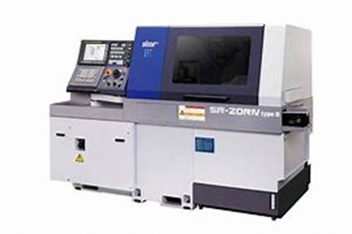
Sliding head
Star SR-20
• Max. Bar Diameter 20mm.
- Max. Component Length 350mm
- Accuracy: .005mm to 0.01mm Dia
- Milling capability: Profiles, Drilling Tapping, Thread
Whirling
- Materials: All steels, Aluminium, Titanium, Silver,
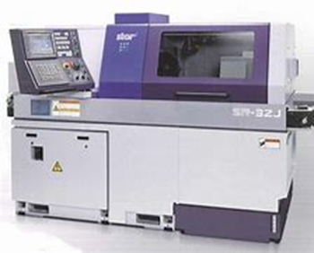
Brass
Star SR-32
• Max. Bar Diameter 32mm
• Max. Component Length 310mm
- Accuracy: 0.010mm
- Milling capability: Profiles, Drilling Tapping, Thread Whirling
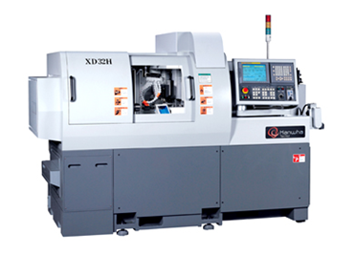
- Materials: All steels, Aluminium, Titanium, Silver, Brass
Hanwha
- Max. Bar Diameter 10mm
- Max. Component Length
- Max. Turned diameter: 45mm
- Accuracy: 0.010mm
- Milling capability: Profiles, Drilling Tapping, Thread Whirling
- Materials: All steels, Aluminium, Titanium, Silver, Brass

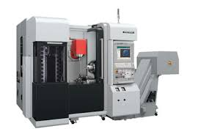
Mill turn
NTX 1000
- Max workpiece diameter = 125mm
- Max workpiece length = 200mm
- Max bar capacity diameter = 65mm
- Max x axis stroke = 455mm
- Max y axis stroke = 105mm
- Accuracy: 0.010mm
- Milling capability: Profiles, Holes, Thread Milling
- Materials: All steels, Aluminium, Plastics, PTFE, PEEK, Nylon, Titanium

Mill turn
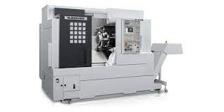
Mori NL 2000
- Max workpiece diameter = 430mm
- Max workpiece length = 450mm
- Max bar capacity diameter = 65mm
- Max x axis stroke = 455mm
- Max y axis stroke = +/-70mm
- Accuracy: 0.010mm
- Milling capability: Profiles, Holes, Thread Milling
- Materials: All steels, Aluminium, Plastics, PTFE, PEEK, Nylon, Titanium

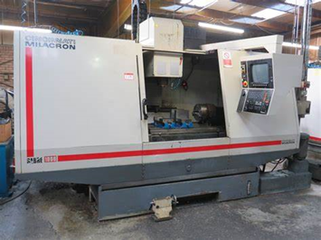

Milling
Sabre
- Max. work piece 2m x 0.5m x 0.5m
- Materials: Stainless Steel, Aluminium, Brass, Copper,
Titanium
- Non metal materials also include: Graphite, ABS, Polycarbonate, Nylon, POM and PEEK.
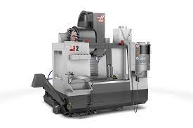
HAAS VF2
- Milling 4 axes
- VF-2 Vertical Machining Centre; 762x406x508mm
- Max X Axis: 762mm
- Max Y Axis: 406mm
- Max Z Axis: 508mm
- Bed size: 762x411mm
- Materials: Aluminium, Steel, Brass, Plastic, Titanium, Silver
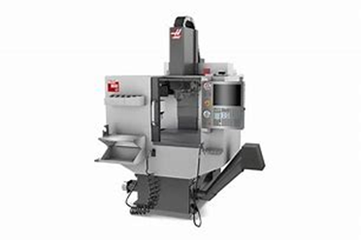
H mini mill 300
• Bar stock size = 10mm/60mm Dia bar stock
• Range = 10mm/60mm collet, billet 370mm
Length = 450mm max
• Accuracy = 0.010mm
- Materials: Materials: Aluminium, Steel, Brass, Plastic, Titanium, Silver

Hi turner
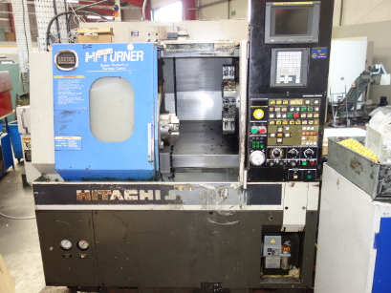
- Bar stock size: 38mm Día Bar stock.
- Max. Machining Diameter : 250mm
- Max. Machining Length: 250mm

3D Printer
- Materials: Variety of Resins. (Tough, Durable, Flexible, Rigid, Polyurethane, Flame resistant)

Digital design
We operate SolidWorks/cam system to handle the Programming, Designing and Engineering of our customers components.
This software has the capability of handling 3D Solid Models, and can produce NC programs for our Mill/Turn Five Axis Lathe, Mill/Turn centre, Vertical Machining Centres integrated with a 4th axis and 3D printer.

To handle the procurement of Materials, Customer Orders, Purchases, Control of Processes, Planning and invoicing we have in place a “MRP”system (REDant). The system has allowed us to consolidate and manage all aspects of our customers’ orders with full traceability and control. We work in accordance with ISO 9001-2015 standard.

